**MG- 800 Strategic Management**

**Professor John Castro**

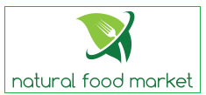

**Business Plan – Natural Food Store**

**Pinal Patel - 0170114**

**TABLE OF CONTENTS**

1. Executive Summary
2. Statement of Mission Goal
3. Company Description
4. Industry Analysis and market trends
5. Target market
6. The Competition
7. Strategic position and Risk Assessment
8. Marketing plan and Strategies
9. Keys to Success
10. Operation Plans
11. Technology plan
12. Management and Organization
13. Community Involvement and Social Responsibility
14. Development, Milestones and Contingency/ Exit plan
15. The Financials
16. **Executive Summary**

In natural food store people can buy organic foods. All kind of foods are available in this store. Organic Vegetables and fruits are also available in the market. This store has herbs, vitamin which contain by natural sources all the things are available in this company. First of all this company would to make one store in south jersey where all the rich people are living and then after this company is going to make channel of the store. Nearby this store at this company don’t want any organic store when this company is starting business and this company is also looking for best place where people can easily see the store and come to buy products. This company want to open it nearby 2000 residents’ area. You can say organic food. This company would love to open this store in Long Branch. This area is dense area and I think people are spending money behind natural food or organic food. Our motive is provide fresh and organic foods to the customer. Company is using good marketing strategy to attract the customer.

This company is growing fast in 2016 company net income is $ 26474500. Company has total asset and liabilities are $ 5000000. Company have $ 1000000 cash amount. In 2016 last year company net sale is $ 52030000 and in 2017 expected sale increase is 10% it should be $57233000 and in 2018 projected sale increase is 10%, it should be $ 62956300. So for calculating projected year net sale shows that company is growing.

1. **Statement of Mission:**

Mission statement is important for company. For this company have mission statement is ***“provide good quality health food to people, get good quality healthy food buy people, and give more productivity by healthy food.”*** In the company’s mission statement, provide information like company provide good quality food, people eat healthy food and stay healthy and give more work output.The company mission is only concentrate on healthy quality food. Another thing is that our store is also concentrate on high stander quality food and business.

1. **Company Description:**

This company is opened in Long Branch, New Jersey. This company carry so many items like for organic and natural fruits, vegetables, packet things, frozen, vitamin, fresh food, and juice. This company is dividing in three part first is grocery, second is vitamin section, third is juice bar. In the first section grocery company contain all natural as well as organic in all the food like produce, frozen foods, packets, eggs, meat, chesses, and milk. In the second section vitamin contain all adult vitamin, child vitamin and herbs in the form for tablet, capsule, soft gel capsule and vitamin is in gummy bear too. In the third section juice bar give fresh fruit smoothies and fresh vegetable juice. This company have lot of things which help any kind of group of the people.

1. **Customer value proposition:**

This company operational plan and business model work together and make customer value propositions. This company sell organic food as well as natural food. Apart from this company is focusing in quality of food and loyalty infant of customers. Company hirer sales person, so he or she can sale the product with telling positive side of product to the customer. By selling good quality organic and natural food to taking care about customer’s health. Each and every stage company build their loyalty with customer, and provide them cost benefit with quality benefits. This natural food market provide coupon code to the regular customer as well as company provide mobile order system as well as online order and if customer buy from store, this company give home delivery or pick up option for the customer. Natural food market have direct farmers contact, so this company get product in less price, basically company profit ration is higher.

1. **Business goals:**

**Specific:** This company goal is important because company is thinking about people health and quality of food. In this company have involve people how are more give important to their health instead of buying normal food. In this store manager are their under the manager main persons are nutrition’s, producer and floor manager. All on the top is CEO are there. This company is located in Long Branch, New Jersey. This company buy product from farmers. Get product in cheap price and sell in cheap price.

**Measurable:** this company have good net income after one year like $ 206174. Basically company have good profit after completing one year and next three to five years company gather the profit and open a new store in perfect new place. In this company marketing manager try to achieve goal for year and it is also effect to the company profit margin.

**Achievable:** This company is providing different product to the customer, so people who are working like Monday to Friday and they are preferring to buy all the product from that same place, this store provide that facility to the customer. After the five years company get enough profit margin to open different store in different state as well as different countries.

**Relevant:** For opening this business is right time becausenowadays people are follow healthy like style and organic market is booming industry.

**Time bound:** Firstly, company is going to notice to how much company is going to get profit in first six month and related to those six month company is plan to do market for next six month to improve company’s growths. End of the year, company notice that how many product company sale more product, so next year company is focusing those product as well as another product which sales less and so those product marketing more than famous products. by the help of time bound company can improve that sales and profit market.

1. **Industry Analysis and Trends:**

In Industry Analysis I just want to say that all the grocery stores are not sailing natural, organic fresh food. This company is going to do it. Because of this company have lot of market as well as company have good competitor like whole food store.

In my company strategy is that I just want to open my store on that which don’t have organic or natural food store and I can get more customer on that place. Apart from this this store have lot of product so customer get each and every thing from one place.

In the industry, basically there are two type of seller one is organic food and another one is normal food seller. By the market research, there are so many people prefer organic food. Survey said this, people who prefer organic food they prefer to stay at home and make organic food instead of go out and eat organic foods. Among them 3 out of 4 people compare their foods. 72% people said they want to buy organic food instead of another food. 24% people said that organic food make monthly household costly, so the market is going to run on.

In this pie chart company can conclude that different people have different criterial to eat healthy food in EU and China people more prefer organic food instead of other country people.

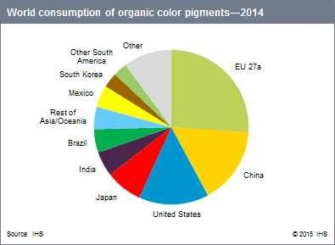

In U.S.A only, company calculate whole organic sales and growth from 2006 to 2015, so company can conclude this in 2006 annual growth is approximately $18 million dollar, after this 2007 almost $20 million dollar, in 2008 and 2009 annual growth is almost same as $24 million dollar, in 2010 annual growth is approximate $28 million dollar. Year by year it is increasing and in 2015 annual growth and sale of the year is $40 million dollar.

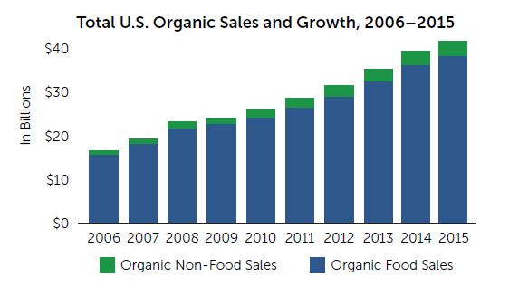

1. **Target Market.**

In this company who are you customers? Those people who are health conscious. They are conscious about their weight and diet, they are the customer. Another one is who have good salary (rich people) because organic food price of more than the regular food. Secondly, market is also depend on age and gender of people, size of family. Target market is a shows that what people need is? Another thing is target market strategy divided market in small segmentation like age, gender, test, geographical location, interest, need and occupation.

**Age:** Nowadays, all age of the people are prefer organic food. All age people are coming in this company because food is necessity of the life and no one can deny it. Apart from this vitamin section is also use full for life like kids don’t eat proper food so parents have to give them multi vitamins. In the old age, all the people have efficiency of vitamins as well as a minerals in their body. Basically all the people have to take multi-vitamin in any stage of life. Instead of this organic food preferred by all the people now because it is not genetically modify.

**Gender:** food is not depend on gender. Al the people need food for live their life but some of the people want to live life in healthy way, so that people prefer to buy natural, organic food products

**Test:** test is big factor for this company. Because each and every place have different food product use by people and they get food for their test purpose. For example: in U.S.A. people are prefer celery, latus, and parsley. But in different country’s people eat different things.

**Salary:** organic food is costly than normal food. In the Long Branch area most of the family are living and their income is also high so company get all kind of customer like any age group, male or female, any religions, and whatever it is small family or big family it means all family size. In this area, customer are loyal to so once company get trust from the customer, customer are going to buy product from this company only. Price, quantity, and quality wise this company is also good because of this also customer follow this company.

Company is going to provide best customer service. For the customer Service Company is going to higher more employee and get review from the customer, give home delivery to the customer, take phone order or online order and do delivery for this products. And at the end give them to fill survey form to know where company have to improve. Basically, company taking care of the customer needs. This company have all kind of payment system like credit card, debit card, gift card, EBT, and cash so no botheration to pay for products.

Most important thing about target market is that it is simply defined who is customer for the company and market is measurable and reachable.

There are major three type of target market. It is consumer market, reseller market, and industrial market. In consumer market is customer who are buy product from the store, what is customer’s test, what they want regularly all his things are depend on geographically. This is the target market for organic grocery sale.

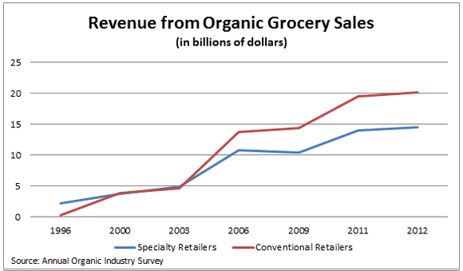

**Geographic:** Market segment is divided people by geography. Different geography people have different needs.This store is only open in New Jersey and after getting good profit, this company is going to growth in different states. This company planning is growth internationally year by years. After U.S.A. Company is planning to open in Canada and after this U.K. company is selecting all the develop state because most of the developed country have good population level and they gave good salary to people and those people are prefer to spend more money on organic and natural foods.

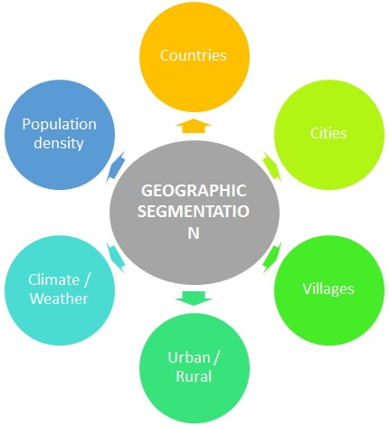

**Demographic:** Demographic is simplest and widest segment type. This company have to make sure that they get good population to buy stores products. Demographic segmentation is depend on Age, gender, income, family size, religion, and nationality. This Company is planning to open in developed country because develop country gives more salary to people ,so those people are prefer to buy organic food and natural food. Another thing is family size is also matter for making profit for the company. If around the business area so many families are living, so company get more customer. And more customer shows more profit. Age is also depended in company’s profit. Nowadays, in this generation people are more conscious about their health and life style. Those linked of people are prefer organic and natural food in the market.

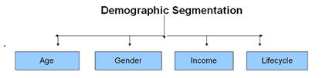

**Behavioral segmentation:** In this part of segmentation, it is depending on behavior, usage and decision making pattern. People have different choice, some people are vegetarian, some are non-vegetarian, and another part is vegan people. So, each and every stage people are eating different food as well as they chose that foods only. Once this store have all of the option for all kind of people, so company get good profit from the business.

**Psychographic segmentation:** In this segmentation, those factors are included peoples lifestyle, activities, interests, opinions. Those all the segment shows how people are behaving when this store is open in local area. In the market their so many people are warried about their health, so those kind of people are follow healthy food store to get healthy life style. Those people think that if they follow healthy life style they give their 100% to the task or job.

1. **The Competition:**

In organic food industry there are competitors who opened from so long. But if I use good strategy plan and advertise my store it is going to come first after few years.

For my business one those stores are not going to affect but another factors are also affect like location, and people who are living nearby.

In this chart shows that which things in the grocery is more sales by the stores or company can consider that which product is more preferable for customer is beverages like 28.9% and after that processed and packaged food is 19.8% on next level of organic food stores. In the third part vegetables cover it in 9.3% ratio. After that fruits are taking fourth position 8.4 % demand in market, and at the end refined grains and whole grains it is like 6.2% and 1.3%market ratio.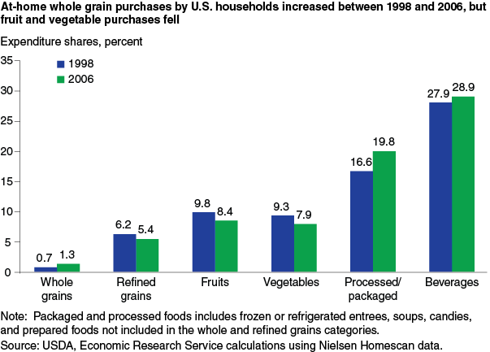

In this chart it is showing that which age group is more prefer organic food. If company want to know which kind of customer they can get it than company can analyses this graph. Company get people who have 20 to 39 age group people are more prefer organic food, than after coming is 40 to 59 age group of people.

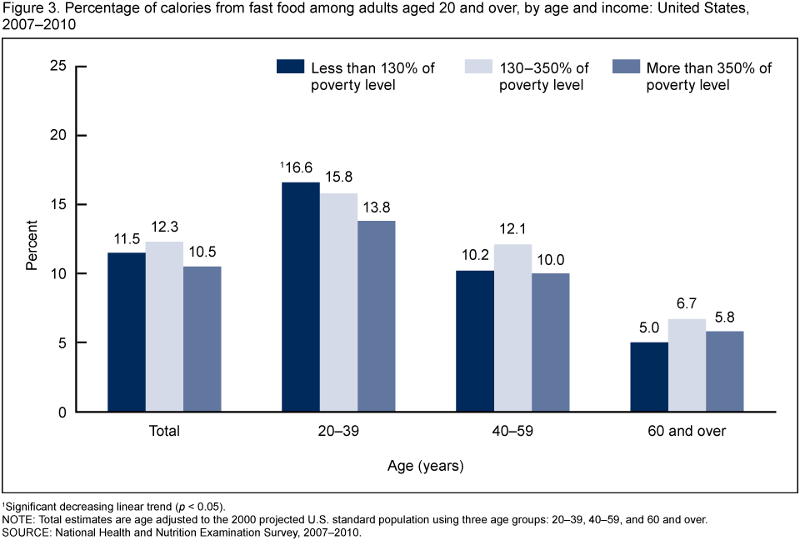

Five force model is help the company to find out competitors in the market and get good sell from the market. In the five force there are five types competitive rivalry, supplier power, buyer power, threat of new entry, and threat of substitution.

**Competitive Rivalry:**

In the natural food and organic food market have extremely strong rivalry. Some companies are already existed and other want to use their luck all are happen because of customer want to buy more organic and natural food. Whole organic and natural food market based on price, quantity, quality, services, and other variables. If this company increase the price of product, customer easily switch to other competitors and lost the customer. So, this company is taking care of quality, quantity, and product price.

**Buyer Power:**

Buyers have Bargaining power and it is very important for any company. Whenever company switching the cost of the product, company concentration is on number of buyers. First of all company get the information about customer needs before changing cost. This company first study about the market price, quality, and quantity of the product. If in any circumstances company increase price of the product and company feel that they are losing the customer than company have to come back immediately on their less price and give some offer to get back those customer.

**Supplier Power:**

In the five force analysis supplier demand is moderate impact in company or market. In all over the U.S.A so many suppliers are available for organic and natural food. Natural food store select the wholesalers, local, national, and farmers for suppling the product, so company get product in cheap price. For the product company is not going to get one product from the same supplier, it is going o take from different supply who give product in less price and good quality. It is also going to help when market have scarcity of the product than company have contact to get that product from the different supplier.

**Threat of New Entry:**

In any market, when new entry is come up, it is big risk for any industry. As same as with us, whenever any new company come up with the new idea in the market it is big risk for the company. It is high percentage of losing the customer. At this time have to give offer to the customer and attract them. The company is also stop to increasing price for the product because it is also harmful for the company.

**Threat of Substitute**:

In the market substitutes are major risk for the business. There are so many product replacement in the market. Once company increase the price of product, customer are finding another company to buy the product. in this case company have to hold their customer and give coupons and offer to attract people.

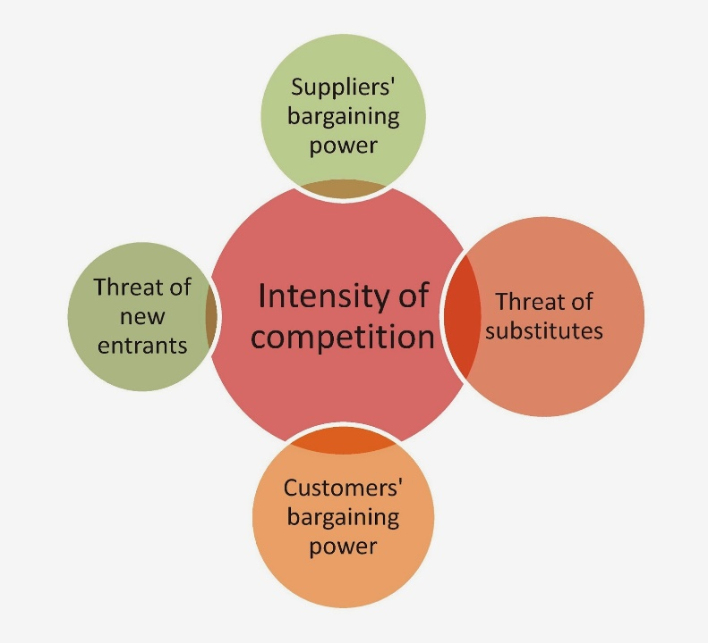

**Strategic map:**

|  |  |  |  |
| --- | --- | --- | --- |
|  |  |  |  |
| customer | Existing market   * Customer Loyalty * Customer satisfaction * Customer needs | New market   * Offer to the customers | Reputation   * Located place * Community of people |
| financial | Revenue growth   * Attract new customer * Entry new product and do marketing | Cost reduction   * Offers for product * Reduce cost | Asset utilization   * More asset using to get product an d attract customer |
| Internal process | Improve customer relationship   * Give more offer/ coupons to the customer * Best quality food * Good customer services | Improve supplier relationship   * More communication and build relation with supplier and get good quality product | Operational   * Less time and money done small things * Good quality foods |
| Learning & growth | Capable Employee   * Employees are well trained * Good customer service | Motivate employee   * To do good work and motivate employee | Well trained employee   * Employee are trained |

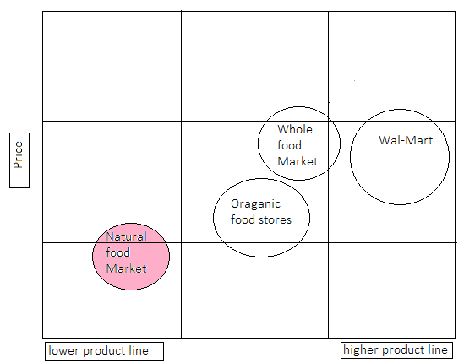

In the strategic map shows that all the store have price level low but in some of the business have high product line. This company have big competitiors in the market like wal-mart, whole food market and somany other organic food stores. Natural food store want to start market in low price so people can attract to the company and company get lot of customers.

1. **Strategic Position and Risk Assessment:**

For natural and organic food product have strategy is that like people eat healthy food and they get healthy life style. The company want to provide high standard food. Company concentrate on customer satisfaction. We have all kind of organic food available in the store.

Marketing research:

In the market, basically there are two type of seller one is organic food and another one is normal food seller. By the market research, there are so many people prefer organic food. Survey said this, people who prefer organic food they prefer to stay at home and make organic food instead of go out and eat organic foods. Among them 3 out of 4 people compare their foods. 72% people said they want to buy organic food instead of another food. 24% people said that organic food make monthly household costly, so the market is going to run on.

In this pie chart company can conclude that different people have different criterial to eat healthy food in EU and China people more prefer organic food instead of other country people.



In U.S.A only, company calculate whole organic sales and growth from 2006 to 2015, so company can conclude this in 2006 annual growth is approximately $18 million dollar, after this 2007 almost $20 million dollar, in 2008 and 2009 annual growth is almost same as $24 million dollar, in 2010 annual growth is approximate $28 million dollar. Year by year it is increasing and in 2015 annual growth and sale of the year is $40 million dollar.



**SWOT analysis**

**Strengths:**

* In the four season, Natural food market give best quality organic food.
* This company have perfect place to stabilized the company
* Company have good motive like company want to provide health food to the people and people maintain their health and get more productivity.
* Company have good marketing strategy.
* Each and every season company give offer to the customer. Not even offer but company give coupon to the regular customer so customer get some amount of from the products.
* Company customer service is good because company have educated employee.
* Company have lot of product like vegan food, all kind of organic vegetables, fruits, meat, eggs, milk product, frozen stuff, and company have juice bar people can get fresh juice instead of frozen or preservative juice.
* Company have social responsibilities in the society.
* Company provide good quality and less price in organic food, so company have good reputation in the market. Company is loyal to the customer.

**Weakness:**

* Lot of competitions are already in the market.
* Sometime organic food have higher price instead of normal food.
* So many people in the market they only follow brand name and company is just started it doesn’t have brand name.

**Opportunities:**

* Organic market id blooming industry in the market right now. People want organic food as much as they can buy.
* Sometimes Brand Company have higher price than local market company, in this case people are coming in natural food store.
* Company are going to make strong marketing plan or cost strategy so company can get more and more customer.

**Threats:**

* Lot of competitors in the market like whole food, So Company have to face hard time.
* Substitute products are available in the market.

This company have lot of good strength with weakness and threat. For weakness company is going to do is use different marketing strategy and attract the people who follow only brand name or who prefer organic food. In ant business competitors are their but once start the business know whole market criteria and lunch product in best marketing way.

1. **Marketing Plan and Strategies:**

In market plan and strategies, company would like to review market first, so company can understand what is going on in the market like how many competitors are there or customer want what kind of products and all this, so accordingly company can plan the business. Company also would to like understanding market activities and how whole system is going on especially product, price, place, and promotion.

We have to make marketing sale strategy also like do online advertising, offers to the customer, and marketing by networking, company web page, print paper and give to the people.

Once company have to capture target market there are four marketing forces price, place, product, and promotion.

**Price:**

Company is trying to maintain long term relationship with customers by the help of marketing strategy plans. Once company et long relationship with customer they don’t have to spend more money for the marketing strategy as well as when company increase price of product, still customer are buying that product. So, company build the trust of customers and loyal to customers. Sometime company have spent some amount of money to attract new customer to aware about the product of the company. This company provide best quality product in reasonable price so customers are defiantly attract to the company. Company is maintaining product values and price to so company is not breaking customers trust.

**Place:**

Location for the company is most important part of the business. Once company get perfect location, company get more customer. Once one store is running properly and company are plan to make another store in some distance of the area. Natural food store opened in to the Long Branch where people are spending money behind organic food and people follow healthy lifestyle. In this area people are afford organic and natural foods.

**Product:**

Natural food store have best quantity and quality product for the customer. When company add new product into the store, company get less quantity of product first and get the survey from the customer if customer like that product than company get more quantity of product in the store. Customer are satisfy with quality of product and price than customer are willing to pay for that product so company want to build that trust. Apart from this company provide vegetarian and vegan food, so that type Customer Company get.

**Promotion:**

Company have to great marketing for the all product. Like company have to do online marketing in social media, T.V., radio, during the shows. Secondly, company have to print poster or give advertise in to the newspaper and send it to the nearest place. Thirdly, company have to give coupon for some free amount on food, so people communicate with each and do communication marketing.

1. **Keys to Success:**

In any business there are two major key of success. First one is you have to satisfy customer need and second one is build customer’s trust. Once this two factors are built than automatically customer come to the business. And after that so many key factors are their like reliability, honesty, openness (whatever customer feel they can say it), compassion.

1. **Key Of Success:**

* Company want customer satisfaction
* Provide good customer services
* Good quality of food
* Storage place
* Person how sale Nutrition’s
* Competitive risk

1. **Operations Plan:**

In the operational plan, company have to take inventory for all of the product, how many product supplier give to the company, how many product company sale in each department, which product company are going to order next. There are so many department in the company who manage all this stuff. Order done by manager, once order come it is arrange by floor employee, storage id handle by storage manager, vitamin handle by nutrition’s, produce handle by produce man, accountant people have different office they are working on all bills and all the financial budget. All the employee roles and responsibilities are fixed and different.

In vitamin section, company is going to order all multi vitamins which are natural, all type of herbs, kid’s vitamins, syrups, all type of natural medicine is in the form of tables, capsule, gel-capsule, powder, and tables. It is almost more than 2000 natural products like herbs and all are available.

Human resources: In the grocery part, there are natural and organic vegetables, fruit, frozen food and all packet things also there. In this department have different company products. In the grocery department there are different kind of parts. First in produce department, there are all types of vegetables and fruits are available. It is like $50 to 60 items over there.in frozen area, there are more than $116 products. At the end in grocery part there are more than $7000 products. In the juice bar, company provide natural organic fruit and vegetable juice and smoothies.

Machinery: in frozen department there are more than 6 frieze. In juice bar there are 2 juicers, 2 mixture blender, one yogurt machine, 1 ice cube machine, 1 frieze. In cashier there are 4 cashier machine with weight meter, 4 monitor, 4 key board, 4 mouse. In produce section 5 open coolers.

Finance requirement: when company get profit, this company is going to open new branch in different area. Apart from this if company need more money than company is going to get bank loan to improve business.

1. **Technology Plan:**

Nowadays, this company have only one store in Long Branch, New Jersey but company is planning to open another store in New York and other states too. Company want to introduce more and more new product to attract the customer and improve product quantity in the store. Once company will introduce new product with new technology in the store, company is going to use good marketing strategy for tamp to people to use that product. This company is going to update the cashier part and make automatic cash register. In this cash register has sense and shopping basket has sensor, so by the help of those sensor customer have to put shopping cart near to the cash register and by the help of robotic system all the thing are packed and ready to go.

Meanwhile company is maintaining product quality, so customer get satisfaction. Another one is one project it means store get success then company using that profit and open another store and after that one by one it is going on.

1. **Management and Organization:**

This company is handle by CEO and by the help of management company make whole chart how whole system is going to work and how much profit company are going to achieve at the end of the year. How much tax company are going to pay.

The company have manager who do all planning, controlling, organizing, leading, and motivating. Manger is the person who have authority to hire employee in department needed. He is deciding which product store needed, order decided by manager and organization is also decided by manager. All the thing is in proper manner in the store and label very well so whenever customer come to the store they get product in same place. Whatever company get profit, 1% part from that company give to the charity to compete social responsibilities.

1. **Development, Milestones and Contingency/Exit Plan:**

Once we started to develop company, at that time first milestone is place (location). Company get good location get customer easily. Another milestone is venders, good vender gives good product to the company and company build the trust of the customer and make a profit from this. Company have to get permission or get certification by FDA. Another milestones is marketing. If company using good marketing strategy plan so company get the customer.

All the milestone achieve by the company and after this company is successful company.

1. **The Financials:**

In this part we have to desire that how much inventory we need. How many equipment we need, how much money we have to spend in to this business, how much we are going to get that back and within how many years. How many dealers are involve in this business?

We have to show the balance sheet, income statement, cash flow statement and at the end of the year we have to pay taxes too.

NOTE: attach excel sheet.

**References:**

<https://livingmaxwell.com/whole-foods-price-comparison-study>

<https://www.ihs.com/products/organic-color-chemical-economics-handbook.html>

<https://www.ota.com/resources/market-analysis>

<https://www.cdc.gov/nchs/products/databriefs/db114.htm>

<http://www.learnmarketing.net/segmentation.htm>

<https://www.designmantic.com/logo-design/samples?page=1&cat=11>

<https://www.smartling.com/market-positioning-strategy/>

<https://www.chiefoutsiders.com/strategic-services/market-positioning-strategy>